Cashmere Valley Pest Patrol: Health and Safety Plan.
Last revised: January 2025

Minimise the risk of an accident  Health and safety is vitally important for all in our community. Please ensure you:  - Are aware of all potential hazards using the table below, each time you head out to check your traps  - Take preventative steps to avoid hazards. Most importantly:  - Where possible, take a friend with you  - Notify others where you are going and how long you expect to be  - Ensure you’ve got adequate clothing and footwear and safety gear such as gloves for handling traps  - Take extreme care when handling traps  - Always carry a basic first-aid kit  - Carry a well charged cell phone with you at all times, check that it has suitable coverage | DO NOT Enter the Reserve:  - If you feel unwell or not up to the task, especially if alone  - During adverse weather conditions such as severe storm/high winds.  - In the event of a fire, exit the reserve any way possible.  CALL 111 IN AN EMERGENCY

Learn from experience
Any accident, no matter how minor (e.g. cuts or bruises), should be reported to the Project Lead as soon as possible. Similarly, please advise them of any potential hazards not listed in the table below, including any community trappers missing or injured while checking traps.
Person/Organisation | Phone No. | Person/Organisation | Phone No.
Lawrence Smith / Project Lead | 021 346 486 | Fiona Hopkins / Project Coordinator | 021 0247 7589
 |  | Dog Control - Christchurch City Council | (03) 941 8999

Safety Matrix
The risk assessment is used to rate the likelihood of potential hazards that may cause harm while checking traps. Hazards can change (e.g. slippery tracks more common during winter months of after a rain event), therefore, the potential for each hazard to cause harm may change from visit to visit.
Use the matrix below to review all identified risks each time you head out, to assess whether you should proceed, given the hazard under consideration and the conditions on the day.
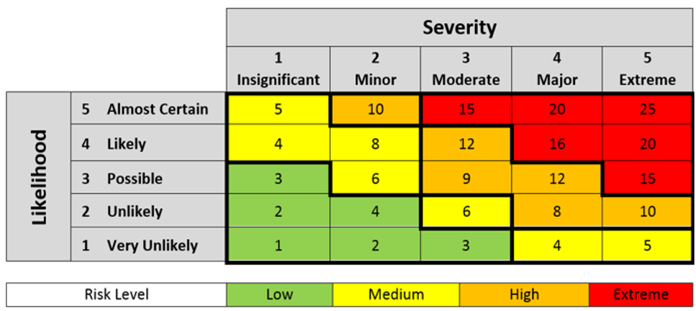
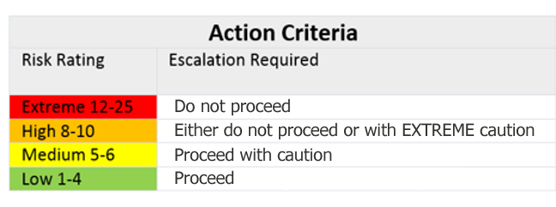

Step 1: Identification of risks and hazards

Process | - Identify all the risks and hazards that the volunteer may be exposed to, guided by the checklist below.  - Transfer identified risks to Risk Management Plan and determine corrective actions/controls to ensure safety of the volunteer(s).  - Review the risks and associated controls with volunteer and sign plan.  - Revise plan if any new risks are identified by any parties.  Note: If the volunteer will not be exposed to any hazards identified below, insert N/A in those fields and provide to the volunteer for their signature.

List of common hazards to consider when preparing the work activities analysis for volunteers.
Hazards are not limited to the list below. All other hazards must be identified and considered during the assessment.
HAZARD | Present Yes or No | HAZARD | Present Yes or No | HAZARD | Present Yes or No
Uneven terrain | Yes | Livestock, dogs, insects | Yes | Misuse of tools / PPE | Yes
Weather – visibility, rain, wind, temp | Yes | Driving / cyclists / electric | Yes | Isolation / cell coverage | No
Open Waterways | Yes | Personal: fatigue, allergies | Yes | Damaged/unsuitable tools | Yes
Vegetation - nettle, thorns | Yes | Inappropriate behaviour | No | Substances hazardous to health | No
Physical work e.g. lifting, carrying | Yes | Children: supervision, vulnerable | No | Fire risk | Yes
Injury from traps | Yes | Poor access/egress | No
Pest borne diseases | Yes | Falling objects (e.g. tree branches) | Yes
Working alone | Yes
Other ________________________ |  | Other _________________________ |  | Other _______________________

Step 2: Assessment of identified risks and hazards

Risk Management Plan
Hazard | Risks | Controls | Potential (refer to safety matrix)
 |  |  | Severity | Likelihood | Risk Level
Uneven terrain | Trips and falls on obstacles or uneven/slippery ground | - Wear sturdy shoes with good tread and ankle support and ensure that boots are firmly laced.  - Keep away from steep or obvious hazard areas.  - Mark out safe access routes and use pathways where possible  - Avoid any obvious hazards such as slippery logs, loose rocks, steep embankments etc.  - Exercise additional caution when walking downhill, e.g. walk across the slope.  - Avoid carrying heavy or awkward sized, objects on uneven ground, or reduce the load being carried.  - Stop work if you have difficulty walking without slipping or falling over | 1 | 3 | Low
Weather – visibility, rain, wind, temp | Hypothermia | - Check weather forecast and wear appropriate clothing  - Wear suitable clothing, warm, layers, waterproof  - Be prepared to postpone if conditions too adverse. | 3 | 1 | Low
 | Hot – sunburn, dehydration, hyperthermia | - Check weather forecast and wear appropriate clothing  - Provide enough water for everyone or tell people to bring their own sunblock, wear hats, sunglasses  - Have rests frequently in the shade / shelter plan work for summer in shady areas if possible.  - Be selective about times of day to conduct work | 3 | 1 | Low
Open Waterways | Drowning, hypothermia | - Wear suitable clothing, warm, layers, waterproof  - Keep away from pond and stream edges especially when working alone  - Do not proceed in high rainfall events or where flood risk is high | 4 | 1 | Medium
Vegetation - nettle, thorns, gorse | Injury from sharp vegetation | - Wear long sleeved clothing and full-length pants  - Scan ahead to check for vegetation that may cause injury | 1 | 3 | Low
Physical work e.g. lifting, carrying | Injuries to self due to physical strain | - Only lift to lift loads within your limit  - Always bend knees while lifting | 2 | 1 | Low
Injury from traps | Injuries to self due to incorrect use | - Complete the training workshop prior to commencing trap line checking.  - Observe best practice whilst handling traps.  - If uncertain about handling traps, ask for additional training.  - Report any damage to traps to project lead. | 2 | 1 | Low
 | Injury to public | - Where practical, traps are secured to location to prevent removal or relocation by the public or animals (e.g. may not apply to traps inside boxes).  - Only trap types approved by CCC to be used in the reserve  - Trap boxes (e.g., DOC 200) must be securely closed (e.g., with a screw) to prevent easy access.  - Traps must be placed at least 2m from tracks and away from areas where children are known to play (wild play areas).  - Traps must be clearly identified labelled and numbered with standard council labels.  - Lures/baits are not poisonous and are not able to be contactable by non-target species such as birds. | 2 | 1 | Low
Pest borne diseases | Exposure to disease causing bacteria carried in rodents and mustelids | - Wear appropriate protective equipment e.g. glasses, gloves, long sleeves  - Clean hands before handling food with sanitiser or antibacterial cleanser  - Be alert for unpredictable behaviour by animals. | 2 | 2 | Low
Livestock, dogs, insects | Dog bite | - DO NOT approach unleashed dogs.  - Remain calm if approached by aggressive dog. Do not run away.  - Call the police (111) if attacked. | 3 | 1 | Low
 | Wasp Stings or Insect Bites | - Mark and avoid wasp nests.  - Carry and regularly use repellent.  - Wear long clothing to minimise skin exposure  - Carry antihistamines and epipen if allergic | 3 | 2 | Medium
Driving / cyclists / electric | Collisions causing injury | - Avoid working on bike tracks and cross tracks carefully, looking both ways.  - Take care crossing all roads  - Remain visible on or near tracks and roads | 3 | 2 | Medium
Working alone | - Being injured while working alone in the field  - Tiredness / loss of concentration. Medical | - Be aware of your physical capabilities, don’t attempt tasks or walking trap lines that exceed them  - If working alone: Mobile phone should be available and working at all times  - Notify another member of the group/family member of your intended activities  - Confirm with member when you have finished and left area | 3 | 1 | Low
Inappropriate behaviour | Physical or verbal attack from stranger(s). | - Advise buddy of your intentions  - Work in pairs where possible  - Carry a mobile  - Phone police (111) if necessary | 1 | 3 | Low
Falling objects (e.g. tree branches) | Injuries to self due to falling objects | - Check forecast, do not proceed if high winds predicted  - Be aware of surroundings at all times | 3 | 1 | Low
Misuse of tools / PPE | Injuries to others or self | - Follow guidelines for safe tool use  - If not comfortable using tools ask for assistance or further training  - Keep clear of people using tools | 3 | 1 | Low
 | Damaged/unsuitable tools | - Ensure all tools are in good working order before use  - Report any damaged tools to the project lead and do not use | 3 | 1 | Low
Fire risk | Injuries to others or self | - Do not proceed when fire risk is high or fires exist | 4 | 1 | Medium

APPENDIX A:

INCIDENT REPORTING FORM

Project name:  Project lead:  Date of incident:  Time of incident:  Site Location: | Injured person:  Name of any witness:  Task being undertaken:
Details of Incident: (Describe what actually happened) | What caused the physical injury? Slip or trip, moving object, lifting etc
Part of body injured:

Severity of injury:  □ Near miss/unsafe act  □ Minor  □ Moderate injury requiring reporting to DOC  □ Serious injury requiring reporting to DOC, is it a notifiable event? Yes/No | Medical treatment required:  □None  □First aid  □Medical treatment (Doctor)  □Hospitalisation
Notifiable event requiring reporting to WorkSafeNZ www.worksafe.govt.nz (only required if group is a PCBU i.e. has at least one paid employee) Y/N

Safety Implications
Immediate corrective action taken, and who and what agencies were notified (if applicable)?

Likelihood of reoccurrence:

Amendments required to safety plan:

Signed:  Name: | Date:

