Trapping Workshop 20 June 2026 – Lee’s notes
The workshop at Living Springs that Lawrence organised was excellent. Lawrence is sending links to all presentations which can then be viewed in conjunction with these notes. There were two presentations before lunch, then two of the four workshops (quarter of us at each). One more presentation after lunch then two more workshops. Morning tea and lunch were excellent and allowed us to chat with other attendees.
Alistair Henshaw – PF Wellington
Alistair spoke about Miramar and future expansion. He stressed that all areas are unique and require different approaches that must change and evolve along the way. Groups need to be a uniting force and work together, learning from each other’s mistakes. For example, taking on the whole Miramar Peninsula at once was their mistake. Better to divide into zones and work in stages. An evolving biosecurity plan is needed. Biosecurity plans need to use high/med/low priority zones.
Social license: There has been a huge increase in birds that the community has noticed. Many were already receptive to the predator control concept because of Zealandia (with tui, kaka and other birds already increasing) so PF Wellington was fortunate. Other parts of NZ might not be so easy.
The community was at the heart of the whole thing, with lots of meetings and sharing of signs of success. The aim is for a trap on every second or third property. PFW provided lots of options for the public to contact them: an 0800 number (where a message can be left), an online report form, social media.
Door knocking resulted in 7,200 households being willing to have traps/bait stations serviced by paid staff and volunteers. There were only 700 declines. Dogs are an important concern – both safety of trap checkers and householder concerns about toxins. Education allays fears about toxins and things such as knowing what day someone will be working from home or when the dog will be at doggy daycare can be factored into planning.
Collaborations: Partner projects where others take on trapping are instrumental in spreading the work. Government House, the airport, hospitals, Victoria University, Te Papa, schools and property companies (some even let PFW liaise with tenants) are all involved.
Data is critical. For example, analysing Trap.NZ enables them to focus on where the rats actually are.
Make the work volunteers do as easy for them as possible. Trap lines should take no more than 90 minutes to check. PFW has locked toolboxes dotted around, mainly on private properties, that contain trap tools, lure, baits, branded vest to wear and so on. The toolboxes are labelled “Toxins” so they aren’t seen as being full of tools. Combination padlocks keep them secure.
PFW surveyed their volunteers and most were able to walk to their line, spend only 3-4 hours per month and think the length of their lines is “about right”. They are a wide range of ages despite PFW expecting it would mainly be retired people putting their hand up to help.
Each zone has a volunteer lead for communicating within zones. A free sports app called Heja is better than WhatsApp and is a great option for asking for someone to fill in and so on but notifications must be turned on.
Toxins are essential for eradication unfortunately. There need to be excellent protocols around toxin use to assure councils, householders and everyone. Locked Pelgar black plastic bait boxes hold four bait blocks and are secured with shock cord and pegs to make them “labrador-proof”. LOLAs made by ZIP (Zero Invasive Predators) are kea and kaka-proof bait boxes. Poisoned rats are removed, frozen in a special freezer kept in a locked storage shed and eventually taken to the local waste station.
Brodifacoum (also used in most household rat baits) bio-accumulates but a cat would have to eat 60 poisoned rats in two months to die.
PFW uses trap lines, chew cards, cameras, community reporting (even if a “rat poo” turns out to be a weka poo encourage the person to keep on reporting), stickers, fridge magnets, welcome brochures, “sorry we missed you” cards, caps, beanies, taxidermy specimens for displays, information posters (which are especially useful for new immigrants who have never heard of predator control) and update reports to keep people informed and interested.
Predator Free 2050 is aspirational but is looking more achievable as momentum grows. Well-trained volunteers are essential, as is technology. Work is being done on norbormide, a rat-specific toxin that doesn’t bioaccumulate.
It is important to reinforce networks such as politicians, DOC, councillors, council pest management staff, Menzshed, Mitre 10 and so on.
Lawrence Smith – Cameras Refer to slides showing types of cameras from simple to hi-tech
Lawrence replaced Tim Sjoberg, Pest Free Banks Peninsula, who was unable to attend.
Lawrence spoke about the use of cameras. He suggested starting small by trying them in your backyard to get used to them. They show what other monitoring tools like chew cards and tracking tunnels miss. They are a great monitoring tool for comparing data from the same time of year. Be mindful about not sharing photos of dead animals because of public sentiment.
Bex Dollery – Waimakariri District Council
Bex is part of the biodiversity team and works closely with Richard Chambers, Pest Free Waimakariri.
Bex stressed the importance of knowing your objective and monitoring (including unintended changes in non-target species such as increased rabbit numbers eating more vegetation). Invertebrates spring back more quickly than other native creatures and are easily monitored. Five-minute bird counts can be good. Trap.NZ has a bird count function. Councils sometimes share bird data. The Merlin app helps identify bird calls.
A simple way to monitor invertebrates is using large wooden log slices/discs that some sawmills give away. They mimic rotting timber in a forest and protect lizards and invertebrates. They are typically pine offcuts 10cm thick and 50cm in diameter. They are left in place, possibly labelled so no-one removes them, and checked four times per year. One person has their camera ready, the other quickly lifts the disc for a photo to be snapped quickly then the disc is gently replaced. Someone commented that it would be a great school project.
[Lee found a great explanation at kakariki.org.nz/monitoring/ that had advice such as leave one month at first and she found some local sawmills to try: Kenneally, Kaiapoi 03 327 2050; McVicar, Harewood 03 359 8144; Westco, Aranui 03 388 1762 and Halswell Timber 03 338 9199.]
Vegetation monitoring can be marked plots comparing growth, number of native seedlings or flowers annually. [Photo points are great for showing progress of native plantings.]
Refugia piles [sometimes called lizard lounges] are stacks of wood or rocks that can be checked, mainly for lizards. Moss grazing by hedgehogs is a sign that they are present. [Google tells me they don’t target moss but consume it along with invertebrates.]
Four excellent workshops were conducted by Lawrence and three Pest Free Banks Peninsula staff:
Ollie Rutland-Sims – The Ultimate Set
Possum traps need to be highly visible. There needs to be as much interest as possible. Because flour-based blaze washes away, consider using pieces of white corflute that show up under moonlight. Ollie calls it “permablaze”. Old chew cards could be used. They can be placed on the reverse side of tree trunks from traps to draw possums in. They can be fixed or flapping in the breeze. It’s good to have them sticking out from trunks at 90° rather than flat against the tree. Aim for 360° visibility around the trunk. Sometimes CDs are used because they reflect well. Flagging tape adds interest.
Scuffed ground gets all predators interested. So do scent trails e.g. weasels will pick up on rat scent trails because they compete for the same food. Female possum undersides can be rubbed around as can mustelid “bits”. Pre-feeding is extremely important for rats so they go into traps, get food then tell their mates to come, by which time the trap will be set.
Blake Thomson - Trap Placement
Make it as easy as possible for a possum to get to a trap. Place a ramp firmly against a tree trunk, possibly with a stake against the tree if needed. Screw them in place and add a wooden rung they can put their back legs on. Don’t have the rung sticking out past the ramp width where auto traps drop out dead possums or they get caught up.
We were shown an AT220 auto trap which keeps re-luring and re-setting for ages. The black part isn’t a strap but a “rodent ladder” so is meant to hang down. Try to have the trap orientated so a possum gets in easily. A sloping trunk is great and a wooden wedge can improve the angle. Leave it loose so the possum’s death throes don’t cause the trap to come away. They hold the possum for a bit then release it.
An SA2 Steve Allan trap has an advantage over a Flipping Timmy or Trapinator because the possum doesn’t need to grab the lure to activate the trap – it triggers as the possum pushes in.
Check single set possum traps twice weekly in summer when fruit lures go bad quickly. If there are signs of possums but no catches, moving a trap one metre can make a huge difference.
Rats like dark areas so under foliage is ideal. Blaze is effective for rat trapping.
Human smell should be kept off traps and if you need to pee DON’T pee at traps sites because it marks it with strong human smell.
Watch the weather and moon phases. After a storm pests will be extra hungry so are more easily caught. Pre-feed for possums during a full moon then set traps. There will still be plenty of light as the moon wanes and they will be used to feeding from traps.
Lawrence Smith – Running a Trapline
The checklist Lawrence shared isn’t a test but a way of improving what we do. It helps volunteers and isn’t a threat.
Trap: Warning label, number and flagging tape where needed.
Tunnel: Flat and stable. Securing boxes can be done using rebar, waratahs, pegs or even a rock. Put DOC traps into tunnels with screws threaded right to the screw head. Chefade (animal based fat) is good as lure, not Kremelta which is plant-based. Wire sprags around entry points deter pests. Bending them is best because filing or grinding can still irritate pests’ undersides.
Possum traps: 1.2m high is ideal. Possums have “hanging out” trees as well as food trees. They only feed 20% of the time then socialise a lot. Screws holding possum traps can come loose - a wooden backing plate is great then the plate with attached trap is screwed to the tree. Someone suggested screwing the lid of Trapinators down because their camera showed a possum lifting the lid. This also increases safety.
Will Fisher – Maintenance and Yearly Calibration
Some new products will be available soon including a weight checking set with a 50g washer attached to metal chain marked off in increments that is gradually lowered up to 100g. Never calibrate below 50g. A new calibration tool means traps needn’t be removed to adjust them. It is placed under the start of the base plate and hammering with a small hammer makes the adjustment. Remember to check screws holding traps in if not removing trap to calibrate. Slogged out screw holes mean it’s time to turn the trap around and, of course, the centre baffle so the door lines up.
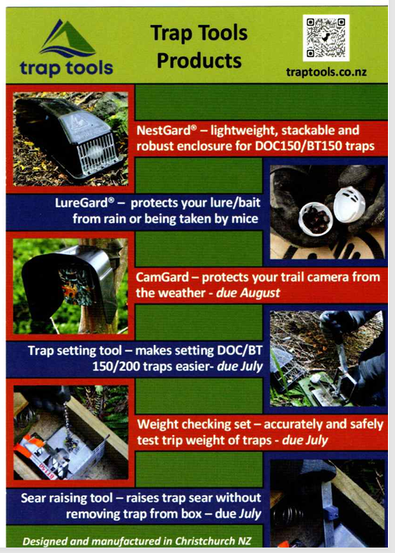
Marcus and Vicki from Traptools set up a display of imminent and available products including LureGards. Not all are on their website yet so here is their brochure.

Note: the new trap setting tool digs into the tunnel edge during use so might not suit softwood timber. - Lee
Will also showed us Connovation’s small trap setting tool which is much lighter than their other type. Will swears by a home-made innovation called a bait cradle. A mesh offcut is curved to resemble half a pipe cut longways and the sprags along one edge are curved back to act as little hooks. The cradle is hung quite high on the rear of the tunnel so cubes of lure are a visual cue and mice can’t get to them easily. If they do, close up the mesh a bit more.
Will suggests cleaning out traps monthly using a scraper, wire brush and odourless rust converter if needed. Watch for wire brush bristles left in traps because if one spikes a pest, it will retreat and not return.
Will showed us a Z.I.P automatic motor lure and the Celium cellular notification system that is especially useful for live capture traps.
It was a great day and we learned lots.

